Design Doc Template

*Author(s): P.Akhila , M.Sai Priyanka ,M. Satya Sai Harshitha ,V.Sai Pranathi*

*Date: 22/05/2019*

*Revision: 0*

*Document Status: Draft [Draft, Completed, Submitted, Reviewed, Final]*

*Project Status: In-Progress [In Review, Approved, In-Progress, Completed]*

Revision History

|  |  |  |  |
| --- | --- | --- | --- |
| Date | Revision | Description | Author |
| 22/05/2019 | 0 | Initial draft of the design doc template |  |
|  |  |  |  |
|  |  |  |  |
|  |  |  |  |
|  |  |  |  |
|  |  |  |  |
|  |  |  |  |
|  |  |  |  |
|  |  |  |  |
|  |  |  |  |

**Table of Contents**

TOC \o "1-3" \h \z \u IntroductionPAGEREF _Toc9445198 \h4

SummaryPAGEREF _Toc9445199 \h4

BackgroundPAGEREF _Toc9445200 \h4

Definitions, Acronyms, and AbbreviationsPAGEREF _Toc9445201 \h4

Design OverviewPAGEREF _Toc9445202 \h4

RequirementsPAGEREF _Toc9445203 \h4

DocumentationPAGEREF _Toc9445204 \h4

Minimum Viable ProductPAGEREF _Toc9445205 \hError: Reference source not found

Stretch goalsPAGEREF _Toc9445206 \hError: Reference source not found

Future workPAGEREF _Toc9445207 \hError: Reference source not found

Architectural DiagramsPAGEREF _Toc9445208 \h5

System DiagramsPAGEREF _Toc9445209 \hError: Reference source not found

Application Programming InterfacePAGEREF _Toc9445210 \hError: Reference source not found

RecommendationsPAGEREF _Toc9445211 \hError: Reference source not found

User InterfacePAGEREF _Toc9445212 \h6

Data Models and StoragePAGEREF _Toc9445213 \hError: Reference source not found

Service OperabilityPAGEREF _Toc9445214 \hError: Reference source not found

Key Performance IndicatorsPAGEREF _Toc9445215 \hError: Reference source not found

Service Level ObjectivesPAGEREF _Toc9445216 \hError: Reference source not found

Project OverviewPAGEREF _Toc9445217 \h6

Communication and TrackingPAGEREF _Toc9445218 \h6

RisksPAGEREF _Toc9445219 \h6

MilestonesPAGEREF _Toc9445220 \h6

Project PhasesPAGEREF _Toc9445221 \h6

CostPAGEREF _Toc9445222 \h6

Frequently Asked QuestionPAGEREF _Toc9445223 \h7

ReferencesPAGEREF _Toc9445224 \h7

AddendumPAGEREF _Toc9445225 \h7

**Introduction**

**Summary**

Generally, there is a high chance of getting seizures for infants and if it is not detected at the right time it may lead to problems. So to tackle this problem we designed a device which monitors child's temperature and seizures and indicates it to the nearby person through buzzer.

**Background**

Sudden increase in body temperature of an infant has a high chance of leading to febrile seizures which is a convulsion caused by abnormal electrical activity in the nerve cells of the brains. The seizures could turn out to be fatal if not detected at the right time.

There are no such existing tools which monitors both temperature and seizures till now. But there is a device designed by Bang good Intelligent Wearable thermometer which monitors only temperature.

By using our device we are able to monitor seizures also.

**Definitions, Acronyms, and Abbreviation**

Febrile: Feverish.

Convulsion: Irregular movement of the body.

Design Overview

**Requirement**

The customers should be economically feasible to purchase our device.

Capital is required to buy raw materials i.e. LM35, SW420 sensors, buzzer, Arduino nano, to pay government taxes and for Up gradation.

**Documentation**

**Wiki pages required:**

<https://www.ncbi.nlm.nih.gov/pmc/articles/PMC4198953/>

**Code comments:**

Temperature and vibration sensors are interfaced with Arduino and coded in the Arduino IDE to extract the values of these sensors. The temperature sensor give the value in millivolts are converted to the Fahrenheit.

**Presentation:**

<https://github.com/SaiPranathi22/My-Project/blob/master/Smart_temperature_and_Seizures_monitoring_System.ppt>

**Minimum Viable Product :**

Our Device consists of a temperature sensor and a vibration sensor which are interfaced with the Arduino nano based on the predicted results the Buzzer beeps.

**Architectural Diagram :**

**System Diagram:**

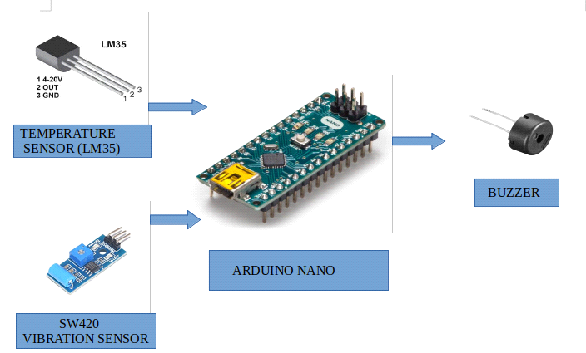

**UML Diagram :**

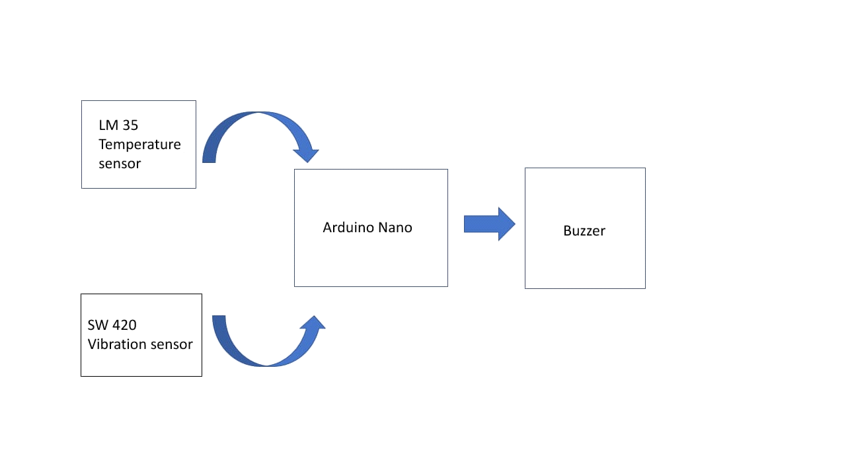**User Interface:**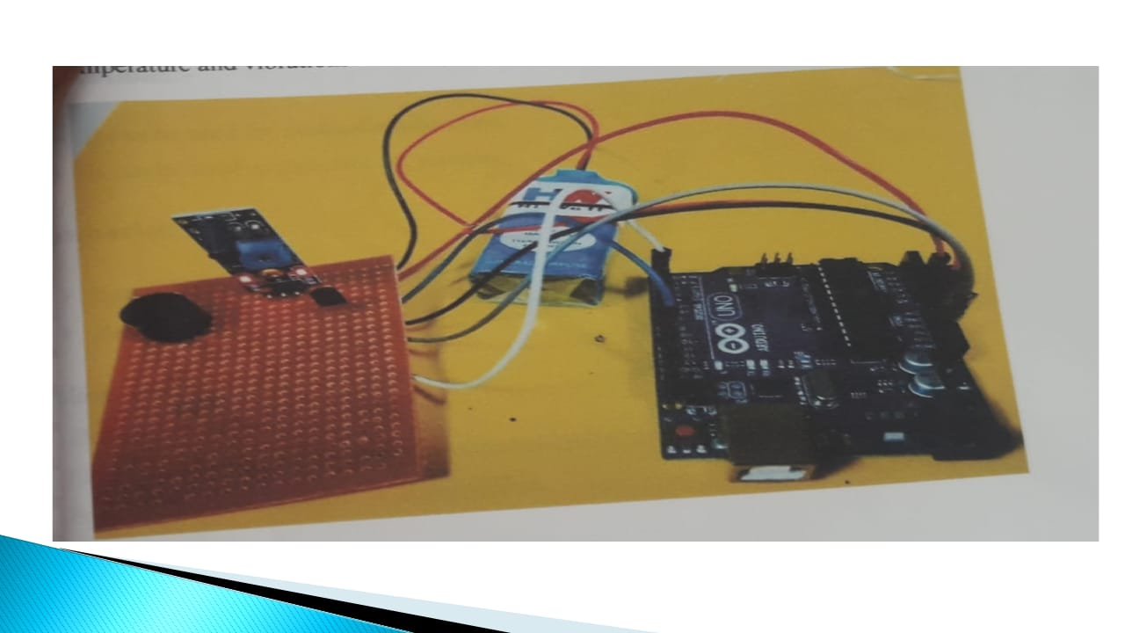

**Project Overview :**

**Risks :**

Failure of working components and discharging capacity of battery.

**Milestones:**

An attempt to make our device compatible.

**Project Phases :**

Firstly we have a device of detecting febrile seizures which occur during fever. After conducting marketing survey we came to know the symptoms of occurrence of seizures. Now we modified our product to detect the seizures due to muscular movements.

**Cost :**

A Month ago we started our work by collecting the data for selection of components which are more efficient to our project and continued to work with a prototype during construction of the prototype we have calibrated the results.

After completion of the prototype we consulted pediatricians to know the actual information about our idea and implemented. According to the pediatricians consultancy we modified our prototype and conducted customer survey.

From conversion of prototype to a product we are working from 2 weeks.

**Frequently Asked Question:**

**References :**

<https://www.healthychildren.org/English/health-issues/conditions/head-neck-nervous-system/Pages/Febrile-Seizures.aspx>

<https://www.mayoclinic.org/diseases-conditions/febrile-seizure/symptoms-causes/syc-20372522>

<https://www.researchgate.net/publication/228901321_Monitoring_Body_Temperature_of_Newborn_Infants_at_Neonatal_Intensive_Care_Units_Using_Wearable_Sensors>

**Materials used and Fabrication :**

**T**o optimize functionality and infant comfort, the design moves sensors and foam to an invisible background for user friendly interface.

The temperature sensor is isolated using soft cotton foam. Flexible and soft conductive textile wires are applied as connections.

**Circuits and interface :**